Available online at [www.sciencedirect.com](http://www.sciencedirect.com/)



AASRI Procedia 3 (2012) 667 – 673

2012 AASRI Conference on Modeling, Identification and Control

Contribution to Characterization of Vitroperm Based Composites

Radovan Bureša*, Mária Fáberováa, Magdaléna Strekováa, Peter Kollárb, Ján Füzerb

*aInstitute of Materials Research of Slovak Academy of Sciences, Watsonova 47, Košice, 040 01, Slovakia*

*bInstitute of Physics, Pavol Jozef Šafárik University in Košice, Park Angelinum 9, 040 01 Košice, Slovakia*

**Abstract**

Vitroperm (Fe73Cu1Nb3Si16B7) 800 flaky powder was studied from viewpoint of granulometric composition, particle morphology, density and resistivity. Composites based on Vitroperm powder and phenol-formaldehyde thermosetting resin were prepared. Physical properties of five types of composites with different resin content were analysed. Characterization of the composites includes microstructure, mechanical, electrical properties and their relations. Physical properties are presented as a result of the technology of preparation and obtained microstructure of the composite.

© 2012 The Authors. Published by Elsevier B.V. Open access under [CC BY-NC-ND license.](http://creativecommons.org/licenses/by-nc-nd/3.0/)

© 2012 Published by Elsevier B.V. Selection and/or peer review [under responsi](http://creativecommons.org/licenses/by-nc-nd/3.0/)bility of American Applied Science Research Institute

Selection and/or peer review under responsibility of American Applied Science Research Institute

Keywords: Soft magnetic composites; Powder metallurgy, Magnetic properties; Mechanical properties

# Introduction

Soft magnetic composite (SMC) is well known group of materials for applications as cores (in transformers, electromotors and electromagnetic circuits, sensors, electromagnetic actuation devices, low frequency filters, induction field coils, magnetic seal systems and magnetic field shielding) with three dimensional isotropic ferromagnetic behaviour with the possibility to replace in some applications instead of electrical steel sheets or ferrites [1]. In the SMC ferromagnetic powder particles are surrounded by an electrical insulating film and often exhibit very good soft magnetic properties [2]. Coated insulation materials are not expected to sinter as

* Corresponding author. Tel.: +421-55-7922415; fax: +421-55-7922408.

*E-mail address:* [rbures@imr.saske.sk](mailto:rbures@imr.saske.sk)

2212-6716 © 2012 The Authors. Published by Elsevier B.V. Open access under [CC BY-NC-ND license.](http://creativecommons.org/licenses/by-nc-nd/3.0/) Selection and/or peer review under responsibility of American Applied Science Research Institute doi:10.1016/j.aasri.2012.11.106

well as metallic powder materials. Physical properties in relation to bond-phase content are often subject of the investigation of SMC based on crystalline and amorphous ferromagnetics [3-5].

The aim of this work was to investigate the morphology of powder in connection to microstructure of composite and analyze the influence of resin content on mechanical and electrical properties of Vitroperm 800 (Fe73Cu1Nb3Si16B7) based SMC.

# Experimental Materials and Methods

Commercial amorphous soft magnetic powder Vitroperm 800 (thereinafter VPM) supplied by Vacuumschmelze, GmbH & Co. KG, Germany was used for experimental study. Thermosetting phenol- formaldehyde resin (PFR) as insulation and binder was used. Commercial PFR with mineral filler content about 50 vol.% was supplied by ATM Germany (ATM). Pure PFR without filler was prepared by polycondensation reaction of phenol and formaldehyde with ammonia addition. Size and shape characteristics of VPM particles were analyzed using laser diffraction granulometer Mastersizer 2000 and image analysis software ImageJ [6]. He pycnometer AccuPyc II 1340 was used to measure of density. Terraohmmeter Sefelec M1501P and digital multimeter Keithley 2100 were used to measurement of electric resistance. Mechanical properties were analysed based on measurement of elastic properties using the Impulse Excitation Technique on non-destructive testing system Buzz-o-Sonic, plastics properties and strength were evaluated using Tiratest 2100 testing machine and Vickers hardness tester HPO250. Microstructure of powder and composite was observed using light optical microscope (LOM) Olympus GX71. Morphology of powder and fractures were observed by scanning electron microscope Jeol JSM 7000F.

# Results

* 1. *Characterisation of Vitroperm powder*

Size distribution of VPM powder particles was analysed using two different methods. Results of laser diffraction granulometry (sieve ASTM E11:61) in Fig.1. shows particles distribution from 40 to 500 m with mean size of particles d(0.5)=178 m and volume weighted mean D=191 m.

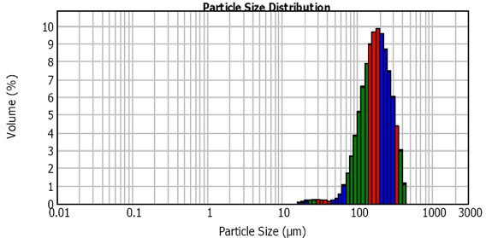

Fig.1. Sieve ASTM E11:61 report made by Mastersizer 2000, mean of 3 measurements.

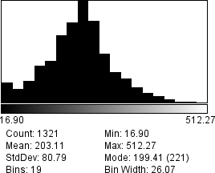 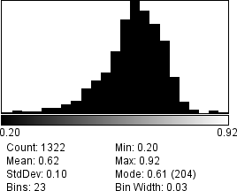 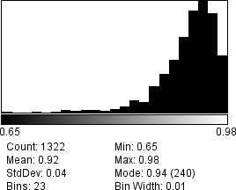

Primary Axes of Fit Ellipse Circularity Solidity Fig.2. Results of image analysis of size and shape characteristics of Vitroperm powder.

This result is in good agreement with measurement by image analysis. Small peak at class of 63 m particles express the thickness of particles due to 2D morphology. Free Vitroperm powder was observed by LOM as documented in Fig.2. Size of particles was fitted using equimomental ellipse and Ferret diameter.

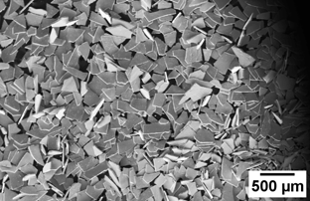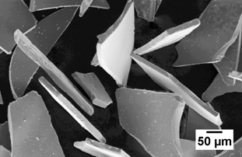

Fig.3. SEM morphology of Vitroperm powder at different scale.

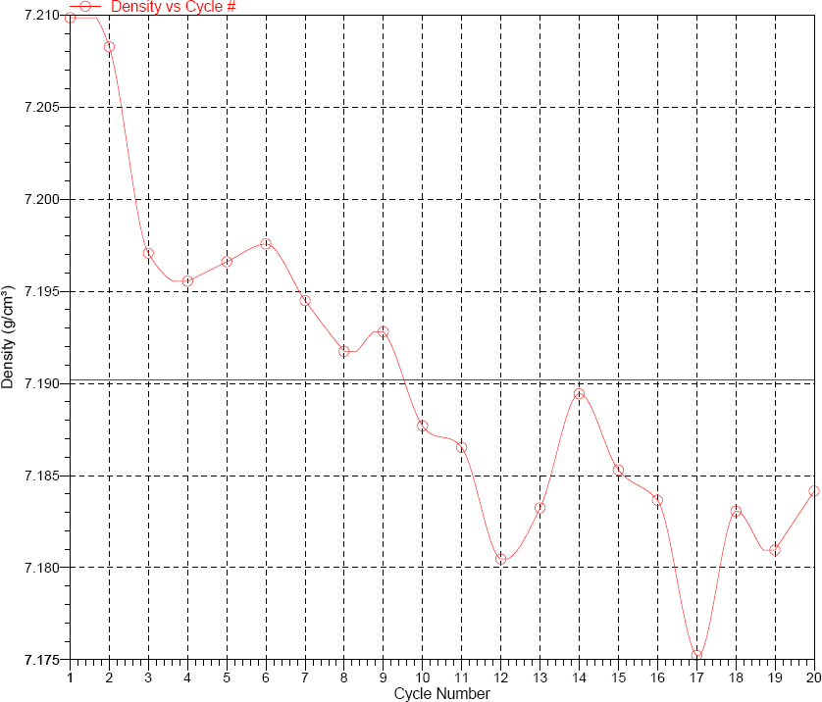

Fig.4. Density changes in 20 measurement cycles of He pycnometry.

Morphology of the powder, in Fig.3., was expressed using shape characteristics: circularity, roundness, aspect ratio and solidity [6]. Mean circularity 0.62 with relatively small standard deviation 0.1 expressed “half” elongated shape with ratio from 2:1 to 3:2 for majority of evaluated particles. Values of roundness confirmed this fact also. Solidity implies of high contribution of convex area to total area of particles.

Helium pycnometry in Fig.4 shows 7.190 g/cm3 density of studied powder. Specific powder morphology required long time and more cycle of measurement in comparison to spherical powders. Vacuumschmelze declare density value 7.35 g/cm3. This small difference in density value is caused by slow oxidation of powder. Specific surface area of the powder calculated from size distribution of the particles is 0.04 m2/g.

Volume resistivity of Vitroperm powder was measured at 5 V DC using bulk brass electrodes at temperature 21ºC and humidity 20 %. The value of the resistivity of free powder was 113 .m.

* 1. *Compaction*

Two premixed composite powders were prepared: a) VPM powder was dry mixed with 5, 10 and 30 wt.% of PFR-ATM. The mixture was wet homogenised with acetone additive and shaked to dry (thereinafter VPM/ATM). b) Resol type phenol-formaldehyde resin prepared by polycondensation reaction was modified with 3- glycidoxypropyltrimethoxysilane (GLYMO) and tetraethoxysilane (TEOS) to be further abbreviated as PFRGT [7]. Prepared PFRGT resin was dissolved in tethrahydrofuran and VPM powder was added to this solution. The suspension was mixed until the complete evaporation of solvent. Composite powder with 3 wt.% of PFRGT was obtained (thereinafter VPM/PFRGT).

Both type of composite powders were cold compacted in close die to shape of bar 4x4x20 mm of size at 800 MPa. Green compacts of VPM/ATM were cured at 165ºC 1 hour in air. VPM/PFRGT samples were continuously cured at elevated temperature with maximum at 200ºC for 12 hours.

* 1. *Characterisation of the Composites*
     1. *Microstructure*

Results of LOM observation of the composites is documented in Fig.5.

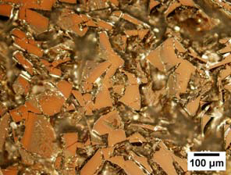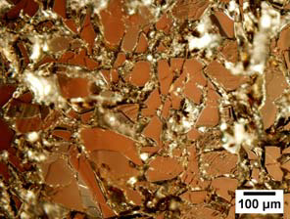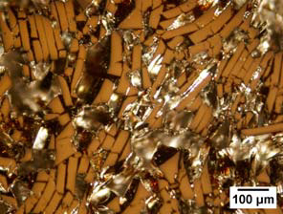

VPM/5ATM VPM/10ATM VPM/3PFRGT

Fig.5. Microstructure of composites observed in polarised light (LOM).

Combinations of images from normal and polarized light were used to optical separation of pores, resin and Vitroperm matrix. The resin covers the VPM particles. The resin electrically insulates conductive particles and creates the mechanical bond after curing. The shape of pores is nearly the same as shape of VPM particles. Spheroidized pores were observed rarely in cured composite. In microscopic level, distribution of the resin is not homogeneous and depends on size and shape of Vitroperm particles. Resin create a uniform

thin layer on flat surface of the particles, but irregular angular shape of Vitropem particles contribute to creation of local micro-heterogeneity. Interparticle voids among angular edges are filled up of large amount of resin. Resin distribution is more homogeneous in the case of VPM/10ATM in comparison to VPM/5ATM due to more resin source. The closest ordering of the VPM particles and the lowest porosity was observed in VPM/3PFRGT composite.

* + 1. *Mechanical properties*

Young’s modulus *E* of composites were measured by non-destructive test by *ASTM E1876*. Hardness *HV10* was measured using Vickers indenter at load 10 kg. Transverse rupture strength *TRS* was measured by three point bending test. Results of the analysis of mechanical properties are summarized in Tab.1.

Table1. Mechanical properties of the composites.

|  |  |  |  |  |  |
| --- | --- | --- | --- | --- | --- |
| Composite | Resin [wt.%] | Density [g.cm-3] | E [GPa] | HV10 | TRS [MPa] |
| VPM/5ATM | 5 | 4.887 | 1 | - | 4 |
| VPM/10ATM | 10 | 4.738 | 7 | 36 | 9 |
| VPM/30ATM | 30 | 3.696 | 16 | 42 | 28 |
| VPM/3PFRGT | 3 | 4.754 | 25 | 71 | 45 |

In general, complex of mechanical properties increase with increasing content of resin. The highest value of mechanical properties shows the sample VPM/3PFRGT. Good mechanical strength at low content of the resin is the result of chemical stabilisation of the resin with GLYMO and TEOS addition instead of dispersed solid filler (amount from 40 to 60 wt.%) as it was in the case of the PFR-ATM. Solid filler was contra productive in the process of consolidation of powder particles. Otherwise, filler stabilise the resin and suppress water vapour evolution during cross linking of the resin. The results are lower mechanical properties, but shorter curing cycle of composite with ATM resin.

* + 1. *Electric Propertie****s***

Results of measurement of the volume resistivity, in Tab.2., shows, that resistivity increases with the content of the resin in the composite material. Higher content of the resin lead to lower porosity and better bond of powder particles. Bond act as insulator, that is why the mechanical properties and the resistivity has the same tendency. Eddy current losses decrease with the increase of resistivity of the material. However, the hysteresis losses increase with increase of porosity and volume content of the resin in the composite.

Table2. Resistivity of the composites.

VPM/5ATM VPM/10ATM VPM/30ATM VPM/3PFRGT



specific resistivity [ m] 3.6 E-3

5.0 E-3

1.9 E-1

2.0 E-3

* 1. *Discussion*

Relations among the physical properties of studied powder and composites are summarized in Figs.6-9. Vitroperm 800 powder is due to flaky morphology more hard compactable in comparison to spheroidal or sponge powders. Specific geometry and shape of powder particle require dedicating more attention to homogenisation and compaction process. With increase of resin content decrease the density of compact due to low specific density of resin. Otherwise, porosity of the composite decrease with increase of the resin volume. Lower porosity and higher density improve the magnetic properties of SMC due to lower hysteresis losses. Lower Eddy current losses are related to higher resistivity. Mechanical properties strongly depend on bond resin content. Modification of resin macromolecule is more effective to improve the mechanical

properties in comparison to filler in the form of dispersoid as it shown in Fig.10. Fracture surface, microstructure and physical properties of composites VPM/3PFRGT point to perspective of development of the composites based on combination of excellent soft magnetic powder and in situ modified resin.

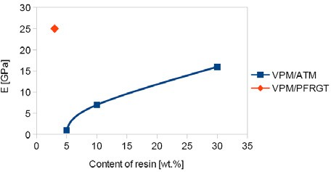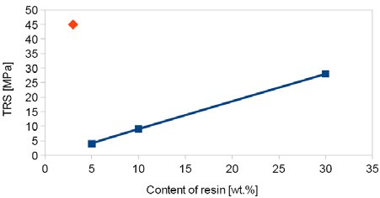

Fig.6. Young modulus vs. resin content. Fig.7. TRS vs. resin content.

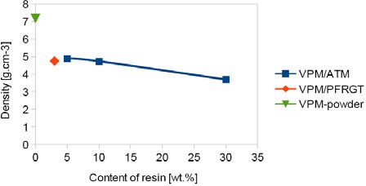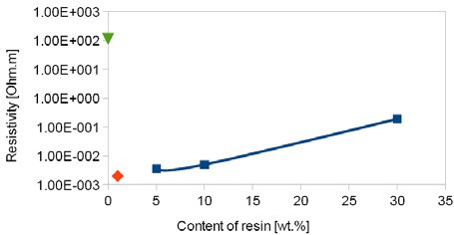

Fig.8. Density vs. resin content. Fig.9. Resistivity vs. resin content.

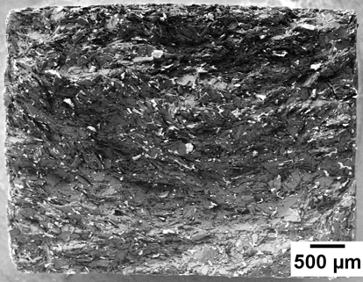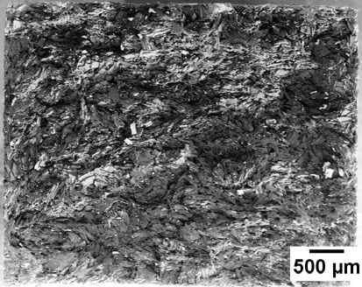

VPM/5PFR VPM/3PFRGT

Fig.10. Morphology of the fracture surface obtained by bending test (SEM).

# Conclusions

Properties of Vitroperm 800 powder and Vitroperm based composites were analysed. Supplied Vitroperm powder had flaky morphology. Powder particles were flat with irregular shape and mostly uniform thickness about 20 m. Mean size of Vitroperm particles is about 200 m. Physical properties of composite based on Vitroperm with bond-insulation resin phase depends on resin content, but filler content or in situ modification of the resin structure is important in relation to compaction technology. Filler is good for stabilisation of the resin in curing process. In situ modification of resin molecule lead to better physical properties, but prolonged the curing cycle. Electric resistivity and mechanical strength are supported by higher resin content. It could be expected that low Eddy current losses due to higher resistivity will be accompanied by higher hysteresis losses. The solution to achieve better physical properties of SMC could be in compromise among a) resin content in composite and filler content in resin and/or b) chemical modification of resin composition and optimisation of curing cycle.

# Acknowledgements

This work was realized within the frame of the project „Advanced technology of preparing of micro- composite materials for electrotechnics“, which is supported by the Operational Program “Research and Development” financed through European Regional Development Fund ITMS:26220220105. This work was also supported by the Slovak Research and Development Agency under the contract No. APVV-0222-10 MAGCOMP. Special thanks to Mr. M. Vitovský, Vacuumschmelze, GmbH & Co. KG, Germany for providing Vitroperm 800.

# References

1. T. Maeda, H. Tyoda, N. Igarashi, K. Hirose, K. Mimura, T. Nishioka, A. Ikegaya, SEI Tech. Rev. 2005; 60: 3.
2. B. Weidenfeller, M. Anhalt, W. Riehemann, J. Magn. Magn. Mater. 2008; 320: 382.
3. E. A. Périgo, S. Nakahara, Y. Pittini-Yamada, Y. deHazan, T. Graule, J. Magn. Magn. Mater. 2011; 323: 1938-1944.
4. Y. Pittini-Yamada, E. A. Périgo, Y. deHazan, S. Nakahara, Acta Mater. 2011; 59: 4291-4302.
5. S. Nakahara, E. A. Périgo, Y. Pittini-Yamada, Y. deHazan, T. Graule, Acta Mater. 2010; 58: 5695–5703.
6. M.D. Abramoff, P.J. Magelhaes, S.J. Ram, "Image Processing with ImageJ". Biophotonics International 2004; Vol.11, 7: 36-42.
7. M. Streková, G. Kabátová, E. Dudrová, . Medvecký, R. Bureš, in: Proceedings of Euro PM Conference Basil: 2012; CD.